**Course Two**

# Get Started with Python



# Instructions

Use this PACE strategy document to record decisions and reflections as you work through this end-of-course project. As a reminder, this document is a resource that you can reference in the future and a guide to help consider responses and reflections posed at various points throughout projects.

# Course Project Recap

Regardless of which track you have chosen to complete, your goals for this project are:

* Understand and assess the proposed scenario
* Demonstrate understanding of the form and function of Python
* Show how data professionals leverage Python to load, explore, extract, and organize information through custom functions
* Articulate findings in a professional summary for cross-functional team members

# Relevant Interview Questions

Completing this portfolio project will empower you to respond to the following interview topics:

* Describe the steps you would take to clean and transform an unstructured data set.
* What specific things might you look for as part of your cleaning process?
* What are some of the outliers, anomalies, or unusual things you might look for in the data cleaning process that might impact analyses or ability to create insights?

**Reference Guide**

This project has five tasks; the visual below identifies how the stages of pace are incorporated across those tasks.

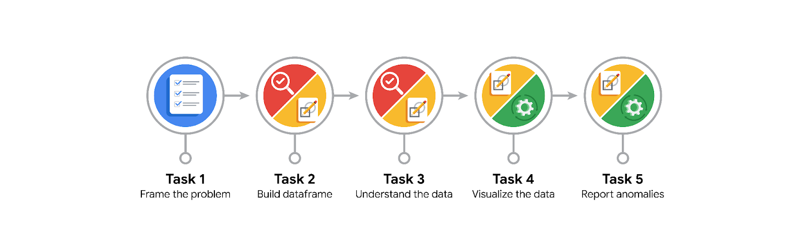

**Data Project Questions & Considerations**

**PACE: Planning Stage**

* How can you best prepare to understand and organize the provided information?
* What follow-along and self-review codebooks will help you perform this work?
* What are some additional activities a resourceful learner would perform before starting to code?

**PACE: Analyzing Stage**

* Will the available information be sufficient to achieve the goal based on your intuition and the analysis of the variables?

**PACE: Constructing Stage**

* How would you build summary dataframe statistics and assess the min and max range of the data?
* Do any data variables averages look unusual? Can you describe the interval data?

**PACE: Execute Stage**

* Given your current knowledge of the data, what would you initially recommend to your manager to investigate further prior to performing exploratory data analysis?
* What data initially presents as containing anomalies?
* What additional types of data could strengthen this dataset?